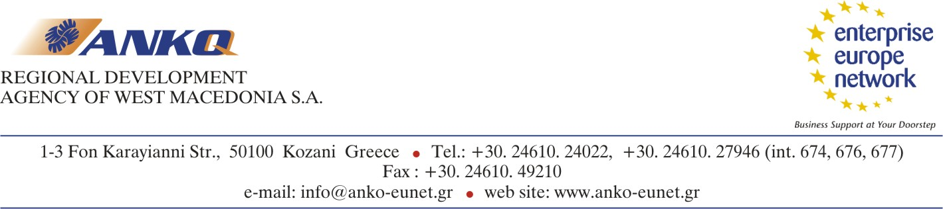

Co-operation Profile

- International Co-operation -

A. Company Profile

Description of the company

Name of the company:
Address:
City:
Postal Code:
Street:
Country:
www (URL Address):
Contact person:
Title:
First Name:
Family Name:
Position in the Company:
Telephone Number:
Fax Number:
E-mail Address:
Year established :
Turnover in million Euro: | up to 2 |  | 2 to 10
Turnover in million Euro: | 10 to 50 |  | More than 50
Number of Employees : | 1 to 9 |  |  | 10 to 49
Number of Employees : | 50 to 249 |  |  | 250 or more
Activity Code (NACE Codes)
Κωδικοί ΣΤΑΚΟΔ:
Contact Languages: | English: |  |  | Others:
Company's Products / Activities
(main products, services, core activities):
Certification/Quality standard: | None | ISO9000
Certification/Quality standard: | ecoaudit | Other:

Already Engaged in Transnational Co-operation: | Yes: | No:
Percentage of Trans-National Activity (defined as approximate % of turnover): | 0% to 9%  50% or more | 10% to 49%

B. Co-operation Proposal

Description of the co-operation sought

Type of Co-operation:
Type of Co-operation: | Trade Intermediary services (agent, representative, distributor) |  | Offered | Required
Type of Co-operation: | Franchise |  | Offered | Required
Type of Co-operation: | Transport / Logistics |  | Offered | Required
Type of Co-operation: | Joint Venture | Offered |  | Required
Type of Co-operation: | Merger, Exchange of Shares | Offered |  | Required
Type of Co-operation: | Sale / Acquisition of a complete company or a part of it | We sell |  | we buy
Type of Co-operation: | Reciprocal Production | Offered |  | Required
Type of Co-operation: | Subcontracting / Outsourcing activities | Offered |  | Required
Target Countries:
Full description:
(Specification of co-operation requested / offered)
Description of the main advantage the company could offer to a potential partner:

C. Partner Profile

Description of the required characteristics of the potential partners

Type of Partners: | Company
Type of Partners: | Other (please specify)
Field of Activities: | Production
Field of Activities: | Services
Field of Activities: | Trade (Buying/Selling)

Number of Employees: | 1 - 9 | 10-49
Number of Employees: | 50-249 | More than 250
Transnational Co-operation Experience: | No preference  Preferred  Required
Expected input / characteristics of the partner (description of what is being expected from the co-operation partner):

